Locus of Points Equidistant from Two Points

Definition
# Source: AI Source: Provided by: [Data Path: Persons Table -> ID Column: 1, Name_En Column: Motasem Essam] -> From: [ChatGPT] on [7/25/2026]
The locus of points equidistant from two fixed points is the set of all points that are at the same distance from both fixed points.
Let $A$and $B$be two distinct fixed points. A point $P$belongs to the locus if:
$$\boxed{PA=PB}$$
The locus is the perpendicular bisector of the segment $\overset{‾}{AB}$.

Simple Definition
# Source: AI Source: Provided by: [Data Path: Persons Table -> ID Column: 1, Name_En Column: Motasem Essam] -> From: [ChatGPT] on [7/25/2026]
The locus of points equidistant from two points is the perpendicular bisector of the segment joining those two points.
For example, if $A$and $B$are 10 cm apart, every point on the perpendicular bisector of $\overset{‾}{AB}$is equally distant from $A$and $B$.
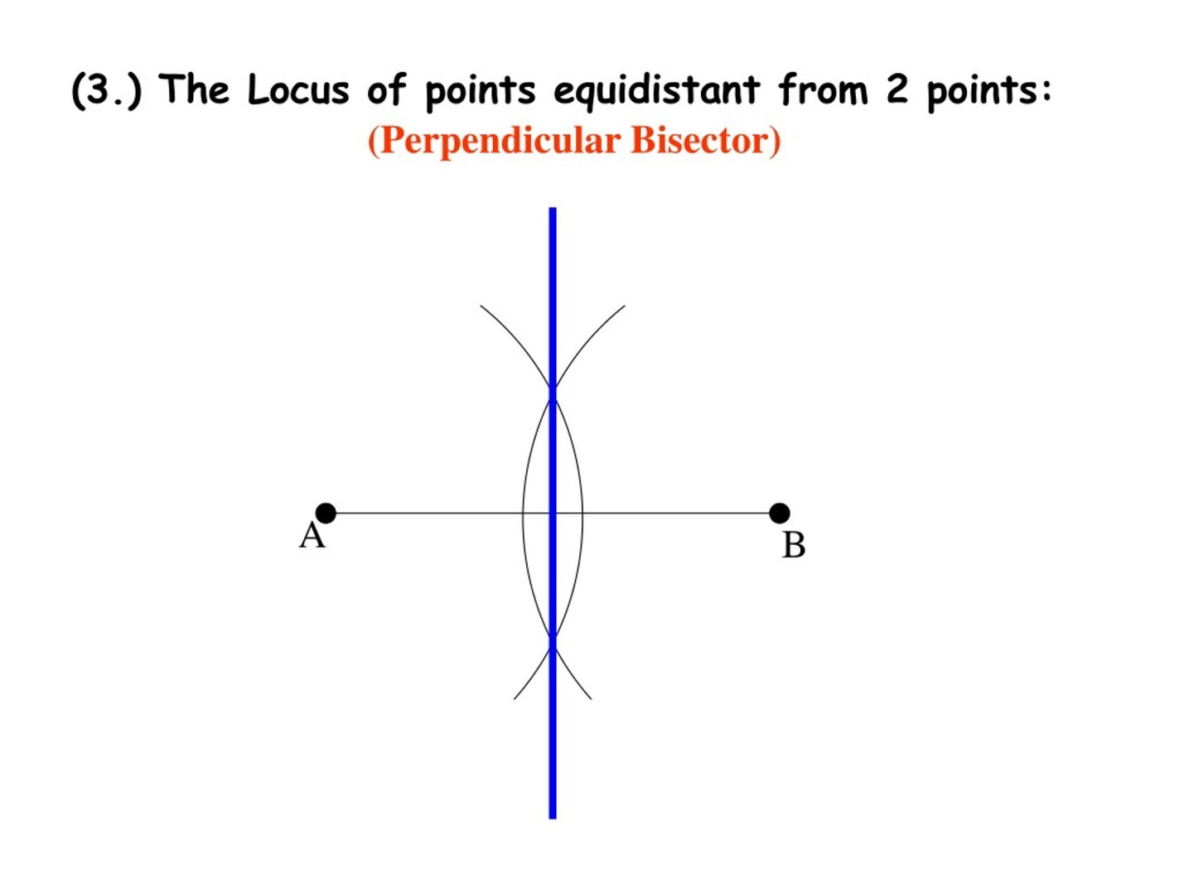
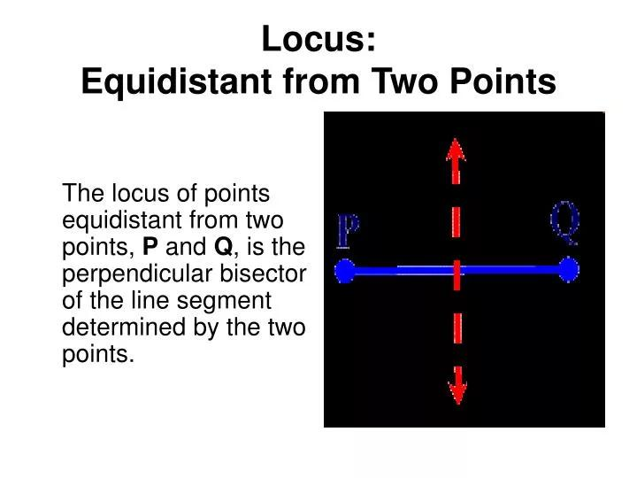
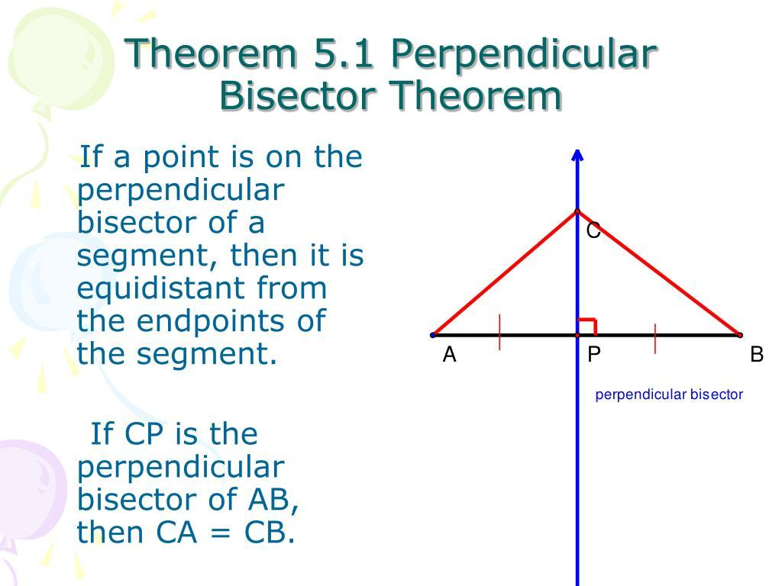
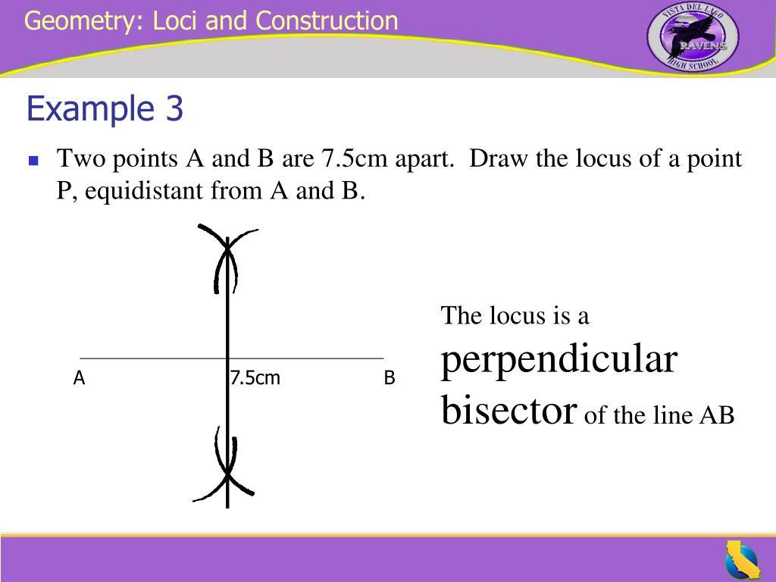
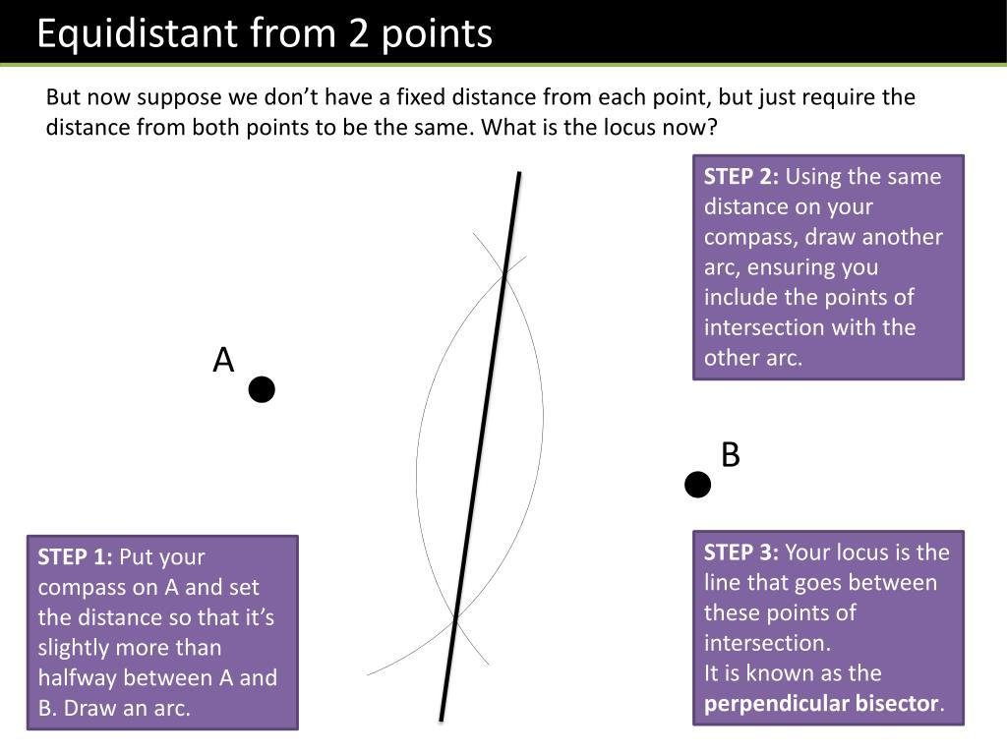

Fundamental Concept
# Source: AI Source: Provided by: [Data Path: Persons Table -> ID Column: 1, Name_En Column: Motasem Essam] -> From: [ChatGPT] on [7/25/2026]
Suppose $A$and $B$are fixed points.
For any point $P$:
$$PA=PB$$
means that $P$is equally distant from $A$and $B$.
There are infinitely many such points.
All of them form one straight line:
$$\boxed{\text{Perpendicular Bisector of }AB}$$
The line has two defining properties:
- It passes through the midpoint of $\overset{‾}{AB}$.
- It is perpendicular to $\overset{‾}{AB}$.
Therefore:
$$\boxed{PA=PB ⟺ P\text{ lies on the perpendicular bisector of }\overset{‾}{AB}}$$

Main Structure
# Source: AI Source: Provided by: [Data Path: Persons Table -> ID Column: 1, Name_En Column: Motasem Essam] -> From: [ChatGPT] on [7/25/2026]
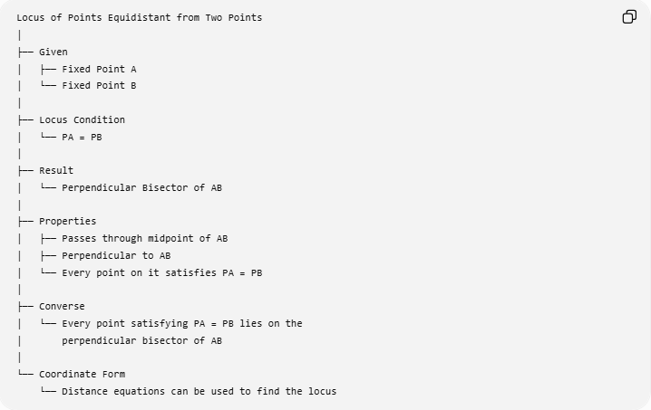
Locus of Points Equidistant from Two Points
│
├── Given
│ ├── Fixed Point A
│ └── Fixed Point B
│
├── Locus Condition
│ └── PA = PB
│
├── Result
│ └── Perpendicular Bisector of AB
│
├── Properties
│ ├── Passes through midpoint of AB
│ ├── Perpendicular to AB
│ └── Every point on it satisfies PA = PB
│
├── Converse
│ └── Every point satisfying PA = PB lies on the
│ perpendicular bisector of AB
│
└── Coordinate Form
└── Distance equations can be used to find the locus

Why Is the Locus a Perpendicular Bisector?
# Source: AI Source: Provided by: [Data Path: Persons Table -> ID Column: 1, Name_En Column: Motasem Essam] -> From: [ChatGPT] on [7/25/2026]
Let $M$be the midpoint of $\overset{‾}{AB}$, and let $P$be any point such that:
$$PA=PB$$
Since $M$is the midpoint:
$$AM=MB$$
Also:
$$PM=PM$$
Therefore, triangles $PAM$and $PBM$have:
$$PA=PB \\ AM=MB \\ PM=PM$$
So:
$$△PAM≅△PBM$$
by SSS congruence.
Therefore:
$$∠PMA=∠PMB$$
These two angles form a straight angle, so each must be:
$${90}^{∘}$$
Thus:
$$PM⊥AB$$
Since $P$lies on a perpendicular through the midpoint $M$, $P$lies on the perpendicular bisector of $\overset{‾}{AB}$.

Converse
# Source: AI Source: Provided by: [Data Path: Persons Table -> ID Column: 1, Name_En Column: Motasem Essam] -> From: [ChatGPT] on [7/25/2026]
The converse is equally important.
Suppose $P$lies on the perpendicular bisector of $\overset{‾}{AB}$.
Let $M$be the midpoint of $\overset{‾}{AB}$.
Then:
$$AM=MB$$
and because the line is perpendicular:
$$∠PMA=∠PMB={90}^{∘}$$
Also:
$$PM=PM$$
Therefore:
$$△PAM≅△PBM$$
by SAS or RHS/HL.
Hence:
$$\boxed{PA=PB}$$
So:
$$\boxed{P\text{ is on the perpendicular bisector }⟺ PA=PB}$$
This is the Perpendicular Bisector Theorem and its converse.

Geometric Construction
# Source: AI Source: Provided by: [Data Path: Persons Table -> ID Column: 1, Name_En Column: Motasem Essam] -> From: [ChatGPT] on [7/25/2026]
Given two points $A$and $B$, the locus of points equidistant from them can be constructed using a compass and straightedge.
Steps
- Draw segment $\overset{‾}{AB}$.
- Open the compass to a radius greater than half of $AB$.
- Draw an arc centered at $A$.
- Without changing the compass width, draw an arc centered at $B$.
- The arcs intersect at two points, say $P$and $Q$.
- Draw line $\overset{↔}{PQ}$.
The resulting line is the perpendicular bisector.
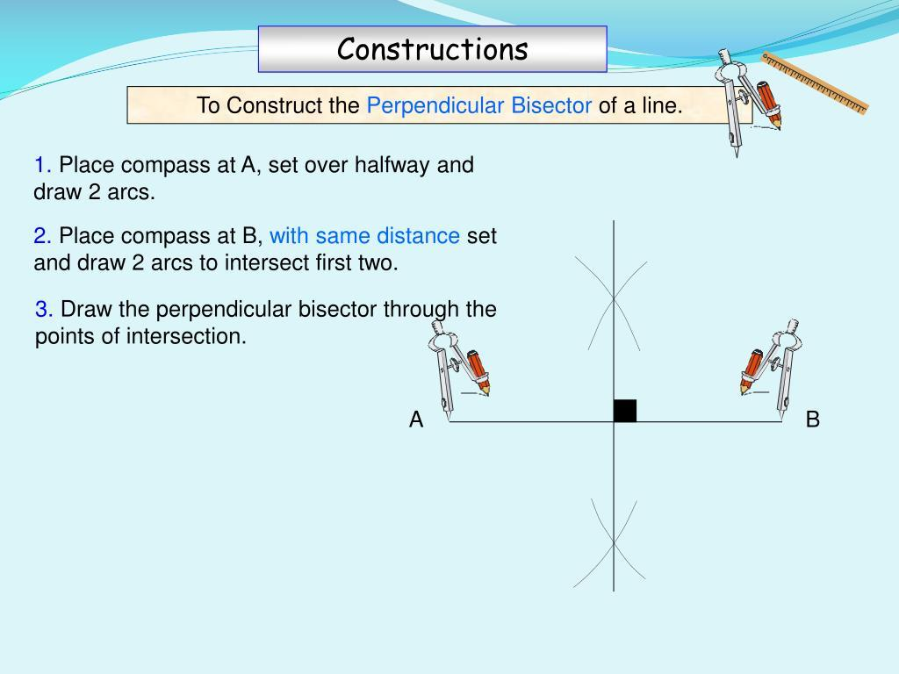
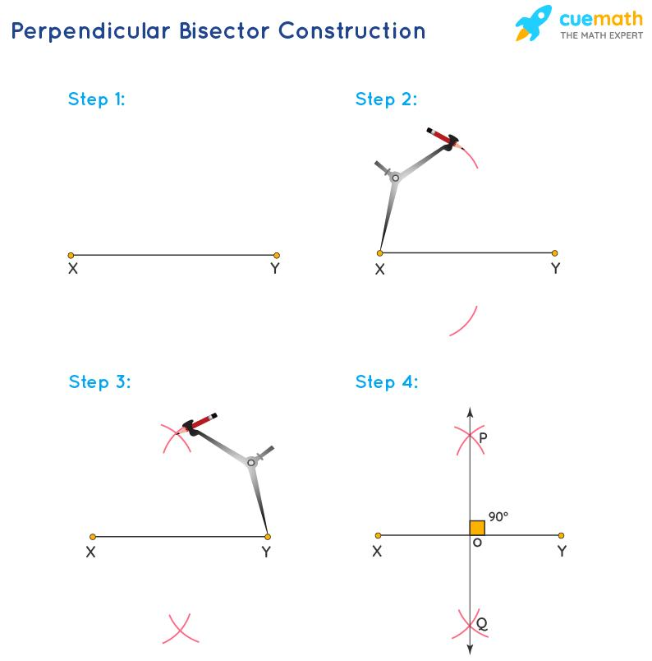
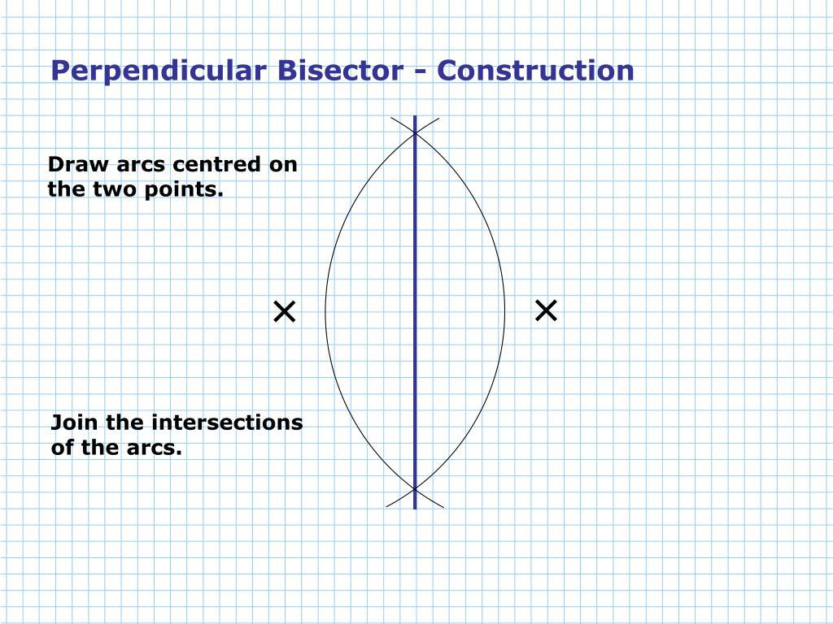
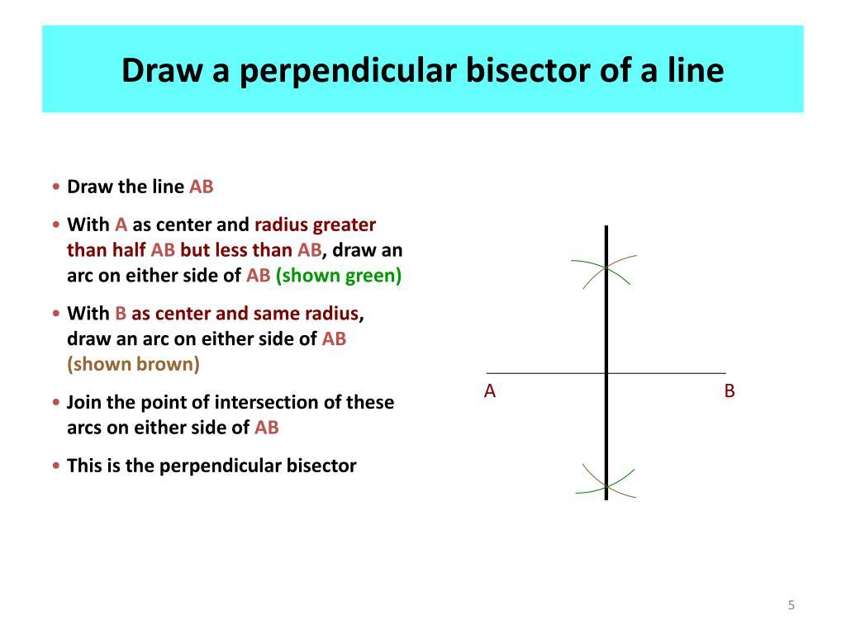
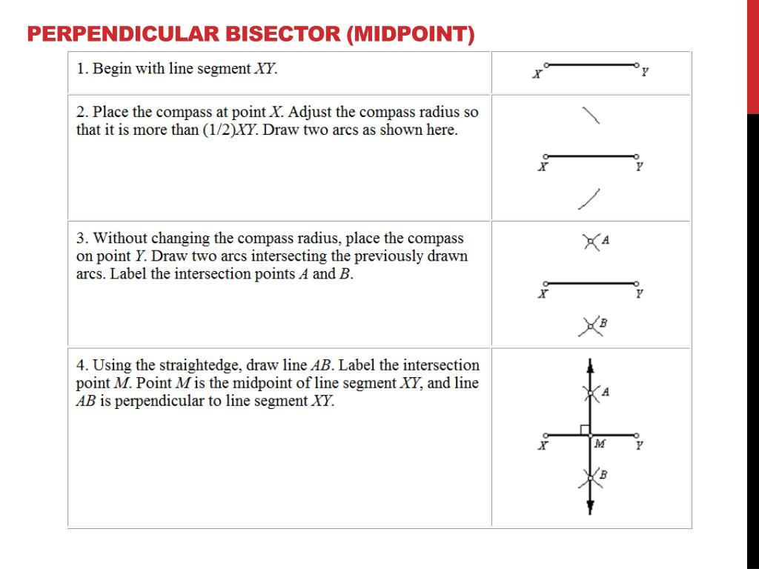
Because:
$$PA=PB$$
and:
$$QA=QB$$
both $P$and $Q$belong to the locus.
Therefore the line through them is the locus.

Coordinate Geometry
# Source: AI Source: Provided by: [Data Path: Persons Table -> ID Column: 1, Name_En Column: Motasem Essam] -> From: [ChatGPT] on [7/25/2026]
Suppose:
$$A=\left(x_{1} , y_{1}\right)$$
and:
$$B=\left(x_{2} , y_{2}\right)$$
A general point on the locus is:
$$P=\left(x , y\right)$$
The condition is:
$$PA=PB$$
Using the distance formula:
$$\sqrt{{\left(x-x_{1}\right)}^{2}+{\left(y-y_{1}\right)}^{2}}=\sqrt{{\left(x-x_{2}\right)}^{2}+{\left(y-y_{2}\right)}^{2}}$$
Squaring both sides:
$${\left(x-x_{1}\right)}^{2}+{\left(y-y_{1}\right)}^{2}={\left(x-x_{2}\right)}^{2}+{\left(y-y_{2}\right)}^{2}$$
After simplifying, the quadratic terms cancel, leaving a linear equation.
Therefore, the locus is a straight line.

Example 1 — Points on the x-axis
# Source: AI Source: Provided by: [Data Path: Persons Table -> ID Column: 1, Name_En Column: Motasem Essam] -> From: [ChatGPT] on [7/25/2026]
Let:
$$A=\left(2 , 0\right)$$
and:
$$B=\left(8 , 0\right)$$
The midpoint is:
$$M=\left(\frac{2+8}{2} , 0\right)=\left(5 , 0\right)$$
Since $AB$is horizontal, its perpendicular bisector is vertical.
Therefore:
$$\boxed{x=5}$$
is the locus.
Every point $\left(5 , y\right)$satisfies:
$$PA=PB$$
For example, take:
$$P=\left(5 , 4\right)$$
Then:
$$PA=\sqrt{{\left(5-2\right)}^{2}+{\left(4-0\right)}^{2}}=\sqrt{9+16}=5$$
and:
$$PB=\sqrt{{\left(5-8\right)}^{2}+{\left(4-0\right)}^{2}}=\sqrt{9+16}=5$$
Thus:
$$\boxed{PA=PB=5}$$

Example 2 — Points not on the x-axis
# Source: AI Source: Provided by: [Data Path: Persons Table -> ID Column: 1, Name_En Column: Motasem Essam] -> From: [ChatGPT] on [7/25/2026]
Let:
$$A=\left(1 , 2\right)$$
and:
$$B=\left(7 , 2\right)$$
The midpoint is:
$$M=\left(\frac{1+7}{2} , 2\right)=\left(4 , 2\right)$$
The segment $AB$is horizontal, so the perpendicular bisector is:
$$\boxed{x=4}$$
Take:
$$P=\left(4 , 6\right)$$
Then:
$$PA=\sqrt{{\left(4-1\right)}^{2}+{\left(6-2\right)}^{2}}=\sqrt{9+16}=5$$
and:
$$PB=\sqrt{{\left(4-7\right)}^{2}+{\left(6-2\right)}^{2}}=\sqrt{9+16}=5$$
Therefore:
$$PA=PB$$
and $P$lies on the locus.

Example 3 — A Non-Horizontal Segment
# Source: AI Source: Provided by: [Data Path: Persons Table -> ID Column: 1, Name_En Column: Motasem Essam] -> From: [ChatGPT] on [7/25/2026]
Let:
$$A=\left(0 , 0\right)$$
and:
$$B=\left(4 , 6\right)$$
The midpoint is:
$$M=\left(2 , 3\right)$$
The slope of $AB$is:
$$m_{AB}=\frac{6-0}{4-0}=\frac{3}{2}$$
A perpendicular line has slope:
$$m=-\frac{2}{3}$$
Therefore, the perpendicular bisector passes through $\left(2 , 3\right)$and has slope $-\frac{2}{3}$:
$$y-3=-\frac{2}{3}\left(x-2\right)$$
So the locus is:
$$\boxed{y-3=-\frac{2}{3}\left(x-2\right)}$$
or:
$$\boxed{2x+3y=13}$$

Special Coordinate Case
# Source: AI Source: Provided by: [Data Path: Persons Table -> ID Column: 1, Name_En Column: Motasem Essam] -> From: [ChatGPT] on [7/25/2026]
If:
$$A=\left(- , a0\right)$$
and:
$$B=\left(a , 0\right)$$
then the midpoint is:
$$\left(0 , 0\right)$$
and the perpendicular bisector is simply:
$$\boxed{x=0}$$
which is the y-axis.
For example:
$$A=\left(- , 50\right), B=\left(5 , 0\right)$$
The locus is:
$$\boxed{x=0}$$
Every point on the y-axis is equally distant from $A$and $B$.

Distance Interpretation
# Source: AI Source: Provided by: [Data Path: Persons Table -> ID Column: 1, Name_En Column: Motasem Essam] -> From: [ChatGPT] on [7/25/2026]
The locus divides the plane into three important parts.
Suppose the perpendicular bisector separates points $A$and $B$.
On the perpendicular bisector
$$\boxed{PA=PB}$$
On the side closer to $A$
$$\boxed{PA<PB}$$
On the side closer to $B$
$$\boxed{PB<PA}$$
Therefore:
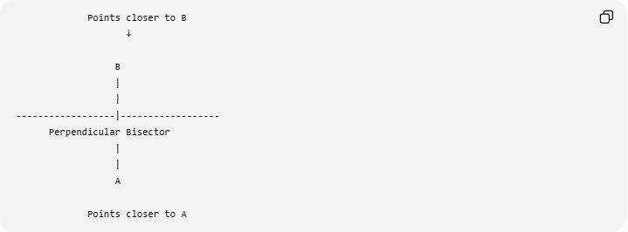
Points closer to B
↓

B
|
|
------------------|------------------
Perpendicular Bisector
|
|
A

Points closer to A
More accurately, $A$and $B$lie on opposite sides of the perpendicular bisector.
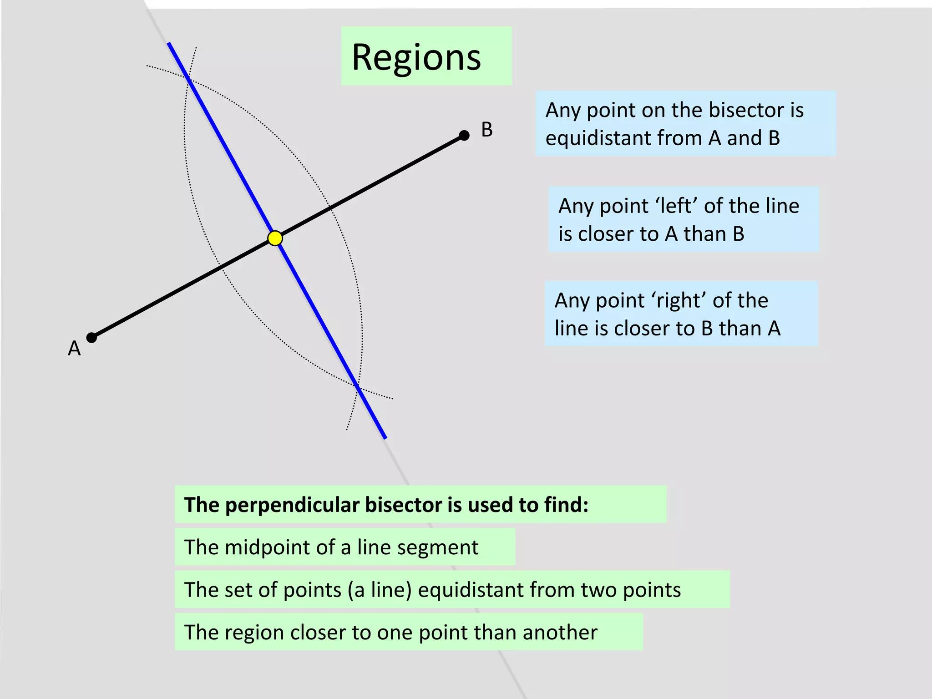
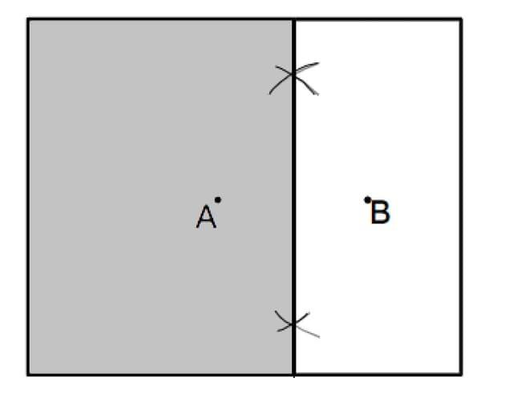
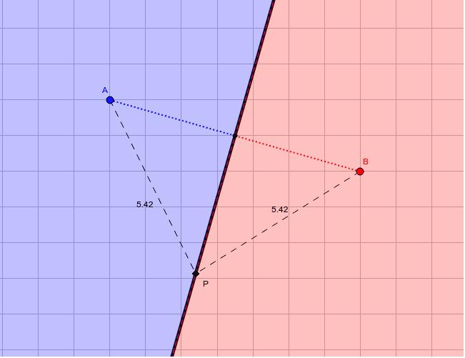
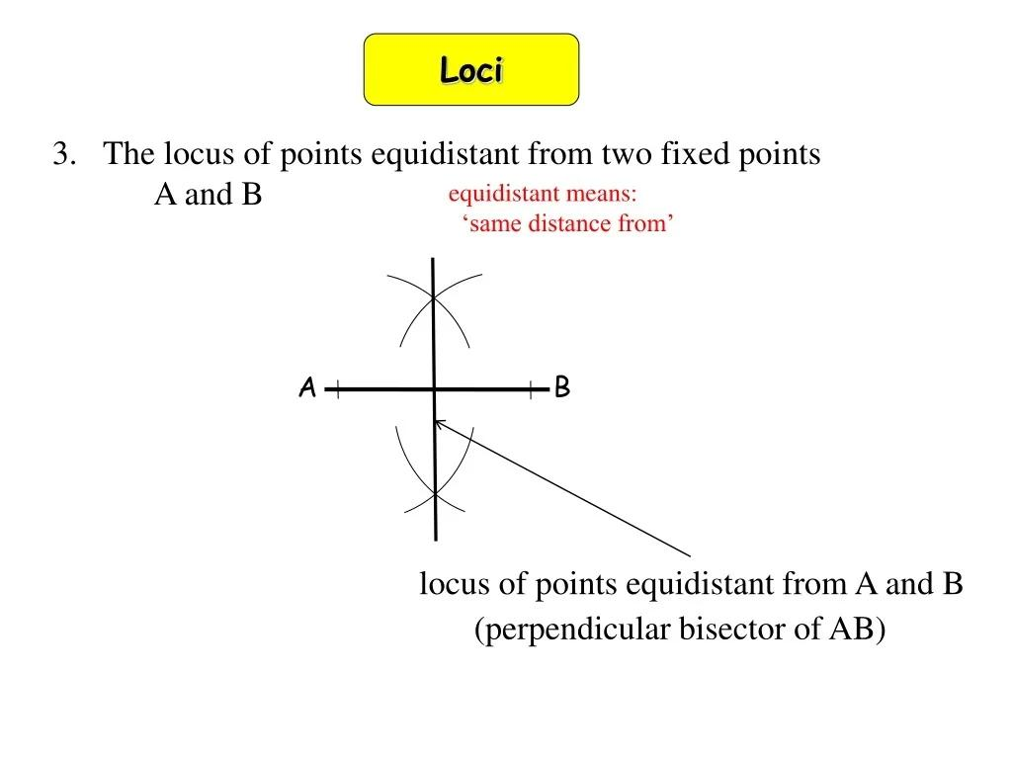

Relation to the Midpoint
# Source: AI Source: Provided by: [Data Path: Persons Table -> ID Column: 1, Name_En Column: Motasem Essam] -> From: [ChatGPT] on [7/25/2026]
The midpoint $M$of $\overset{‾}{AB}$is always on the locus.
Because:
$$MA=MB$$
Therefore:
$$\boxed{M\text{ belongs to the locus}}$$
However, the locus is not just the midpoint.
It is the entire perpendicular bisector:
$$\boxed{\text{Locus}=\text{an infinite straight line}}$$

Relation to Triangle Geometry
# Source: AI Source: Provided by: [Data Path: Persons Table -> ID Column: 1, Name_En Column: Motasem Essam] -> From: [ChatGPT] on [7/25/2026]
If $P$is any point on the perpendicular bisector of $\overset{‾}{AB}$, then:
$$PA=PB$$
Therefore:
$$△PAB$$
is an isosceles triangle.
The equal sides are:
$$PA=PB$$
and the base is:
$$AB$$
Thus, the perpendicular bisector of the base of an isosceles triangle passes through its apex.
Conversely, the perpendicular bisector of $AB$is the set of all possible locations of the apex $P$for an isosceles triangle with:
$$PA=PB$$

Relation to Circumcenter
# Source: AI Source: Provided by: [Data Path: Persons Table -> ID Column: 1, Name_En Column: Motasem Essam] -> From: [ChatGPT] on [7/25/2026]
The locus becomes especially important when finding the circumcenter of a triangle.
For triangle $ABC$:
- Points equidistant from $A$and $B$lie on the perpendicular bisector of $AB$.
- Points equidistant from $B$and $C$lie on the perpendicular bisector of $BC$.
Their intersection is equidistant from all three vertices.
Therefore, the intersection of two perpendicular bisectors gives the circumcenter $O$:
$$\boxed{OA=OB=OC}$$
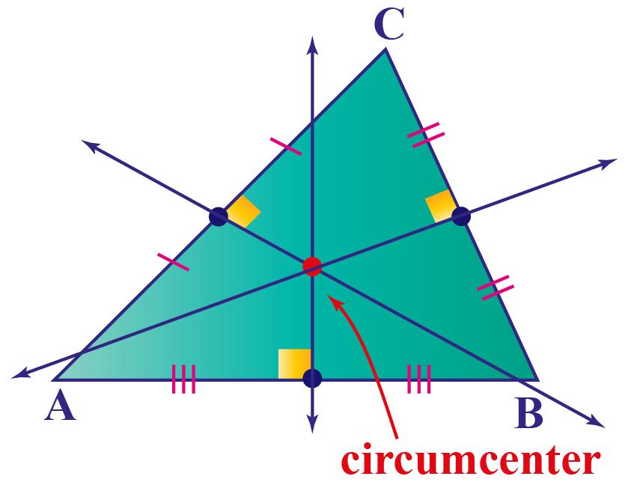
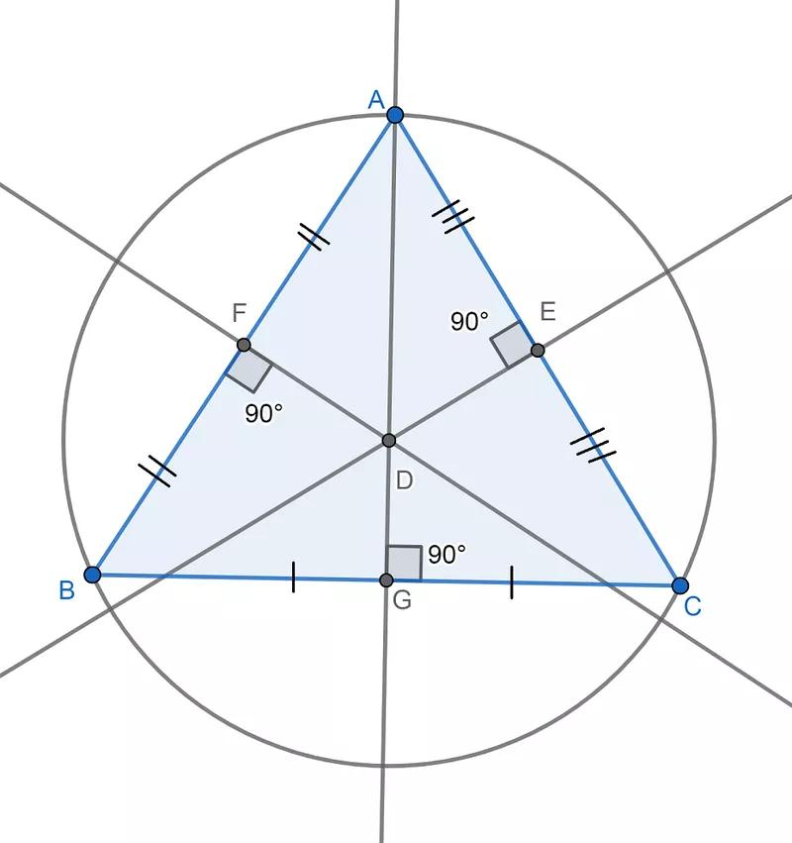
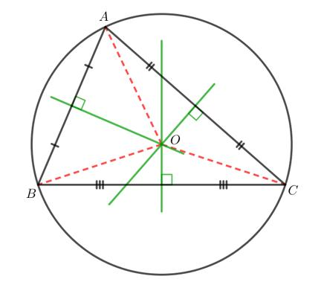
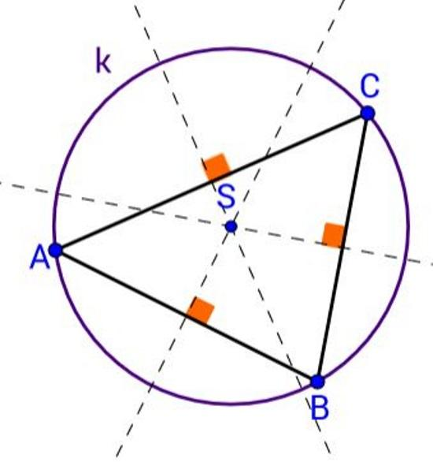
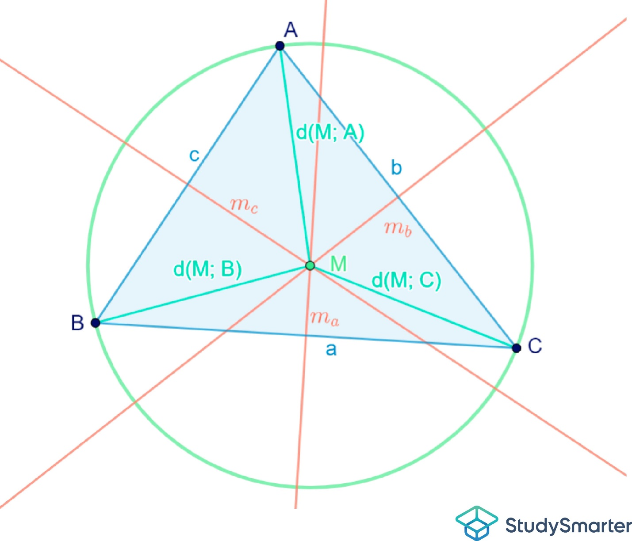

Relation to Voronoi Geometry
# Source: AI Source: Provided by: [Data Path: Persons Table -> ID Column: 1, Name_En Column: Motasem Essam] -> From: [ChatGPT] on [7/25/2026]
The perpendicular bisector also forms a boundary between two regions.
Given points $A$and $B$:
$$PA=PB$$
defines the boundary.
On one side:
$$PA<PB$$
and on the other:
$$PB<PA$$
This idea is fundamental to Voronoi diagrams, where the plane is divided according to which given point is closest.
For two points, the Voronoi boundary is exactly their perpendicular bisector.

Important Properties
# Source: AI Source: Provided by: [Data Path: Persons Table -> ID Column: 1, Name_En Column: Motasem Essam] -> From: [ChatGPT] on [7/25/2026]
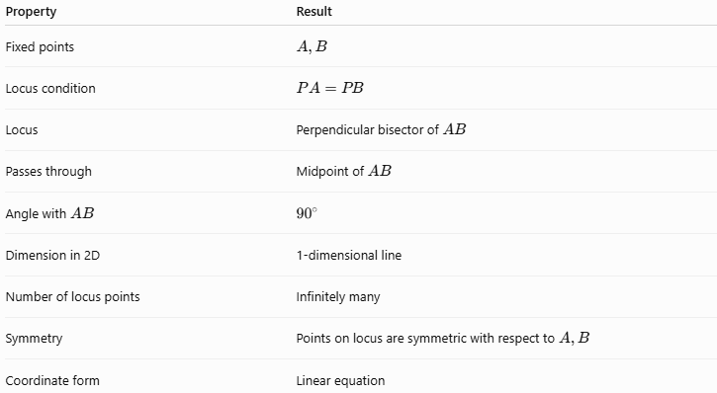
Property | Result
Fixed points | $$A,B$$
Locus condition | $$PA=PB$$
Locus | Perpendicular bisector of $AB$
Passes through | Midpoint of $AB$
Angle with $AB$ | $${90}^{∘}$$
Dimension in 2D | 1-dimensional line
Number of locus points | Infinitely many
Symmetry | Points on locus are symmetric with respect to $A,B$
Coordinate form | Linear equation

Comparison with Other Loci
# Source: AI Source: Provided by: [Data Path: Persons Table -> ID Column: 1, Name_En Column: Motasem Essam] -> From: [ChatGPT] on [7/25/2026]
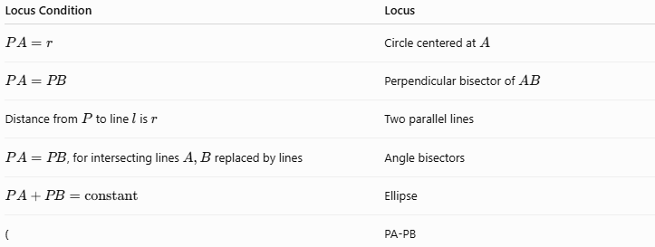
Locus Condition | Locus
$$PA=r$$ | Circle centered at $A$
$$PA=PB$$ | Perpendicular bisector of $AB$
Distance from $P$to line $l$is $r$ | Two parallel lines
$PA=PB$, for intersecting lines $A,B$replaced by lines | Angle bisectors
$$PA+PB=\text{constant}$$ | Ellipse
( | PA-PB
The key distinction is:
$$\boxed{\text{Equal distance from two points}→\text{Perpendicular Bisector}}$$

Classification
# Source: AI Source: Provided by: [Data Path: Persons Table -> ID Column: 1, Name_En Column: Motasem Essam] -> From: [ChatGPT] on [7/25/2026]
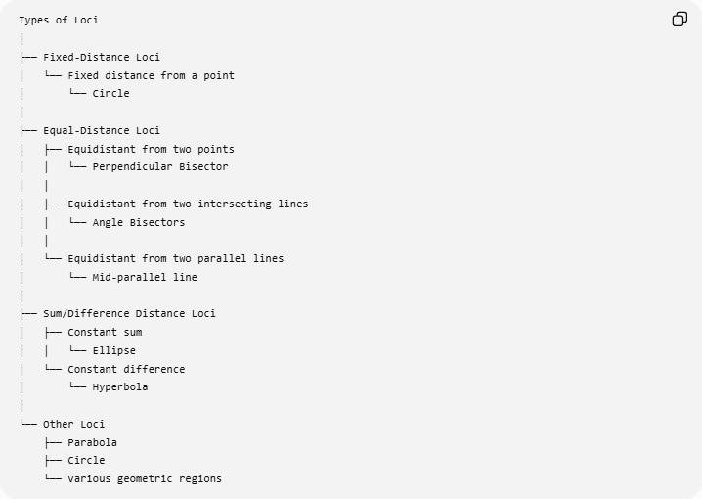
Types of Loci
│
├── Fixed-Distance Loci
│ └── Fixed distance from a point
│ └── Circle
│
├── Equal-Distance Loci
│ ├── Equidistant from two points
│ │ └── Perpendicular Bisector
│ │
│ ├── Equidistant from two intersecting lines
│ │ └── Angle Bisectors
│ │
│ └── Equidistant from two parallel lines
│ └── Mid-parallel line
│
├── Sum/Difference Distance Loci
│ ├── Constant sum
│ │ └── Ellipse
│ └── Constant difference
│ └── Hyperbola
│
└── Other Loci
├── Parabola
├── Circle
└── Various geometric regions

Key Theorem
# Source: AI Source: Provided by: [Data Path: Persons Table -> ID Column: 1, Name_En Column: Motasem Essam] -> From: [ChatGPT] on [7/25/2026]
Perpendicular Bisector Theorem
Every point on the perpendicular bisector of a segment is equidistant from the segment's endpoints.
If $P$lies on the perpendicular bisector of $\overset{‾}{AB}$:
$$\boxed{PA=PB}$$
Converse
Every point equidistant from the endpoints of a segment lies on its perpendicular bisector.
If:
$$\boxed{PA=PB}$$
then $P$lies on the perpendicular bisector of $\overset{‾}{AB}$.
Together:
$$\boxed{PA=PB ⟺ P\text{ lies on the perpendicular bisector of }AB}$$

Important Distinction
# Source: AI Source: Provided by: [Data Path: Persons Table -> ID Column: 1, Name_En Column: Motasem Essam] -> From: [ChatGPT] on [7/25/2026]
The condition is equidistance from two points, not equal distance from a line or from a circle.
Two fixed points
$$PA=PB$$
→ perpendicular bisector.
One fixed point and fixed distance
$$PA=r$$
→ circle.
Two fixed lines
Equal perpendicular distances from two intersecting lines → angle bisectors.
So the defining condition determines the type of locus.

Summary
# Source: AI Source: Provided by: [Data Path: Persons Table -> ID Column: 1, Name_En Column: Motasem Essam] -> From: [ChatGPT] on [7/25/2026]
$$\boxed{\text{Two Fixed Points}+\text{Equal Distance}→\text{Perpendicular Bisector}}$$
For fixed points $A$and $B$:
$$\boxed{PA=PB}$$
is the defining condition.
The resulting locus is a straight line that:
- passes through the midpoint of $\overset{‾}{AB}$,
- is perpendicular to $\overset{‾}{AB}$,
- contains infinitely many points,
- separates the regions closer to $A$and $B$,
- and is fundamental to constructing perpendicular bisectors and finding triangle circumcenters.
Conclusion
The locus of points equidistant from two fixed points is the perpendicular bisector of the segment joining those points. It is one of the most fundamental loci in Euclidean geometry and provides the geometric basis for perpendicular-bisector constructions, isosceles triangles, circumcenters, and Voronoi boundaries.

